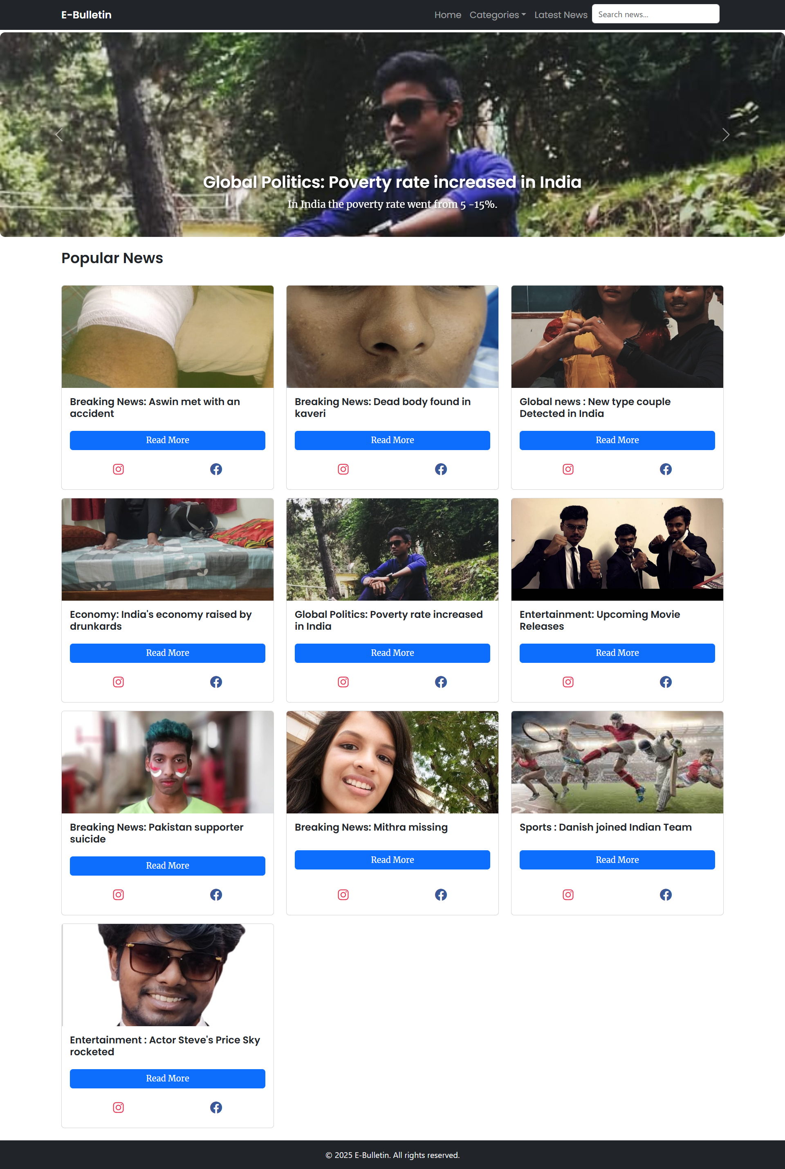

The above image is the index page where the it contains corousel and it has categories and displays popular news   
  
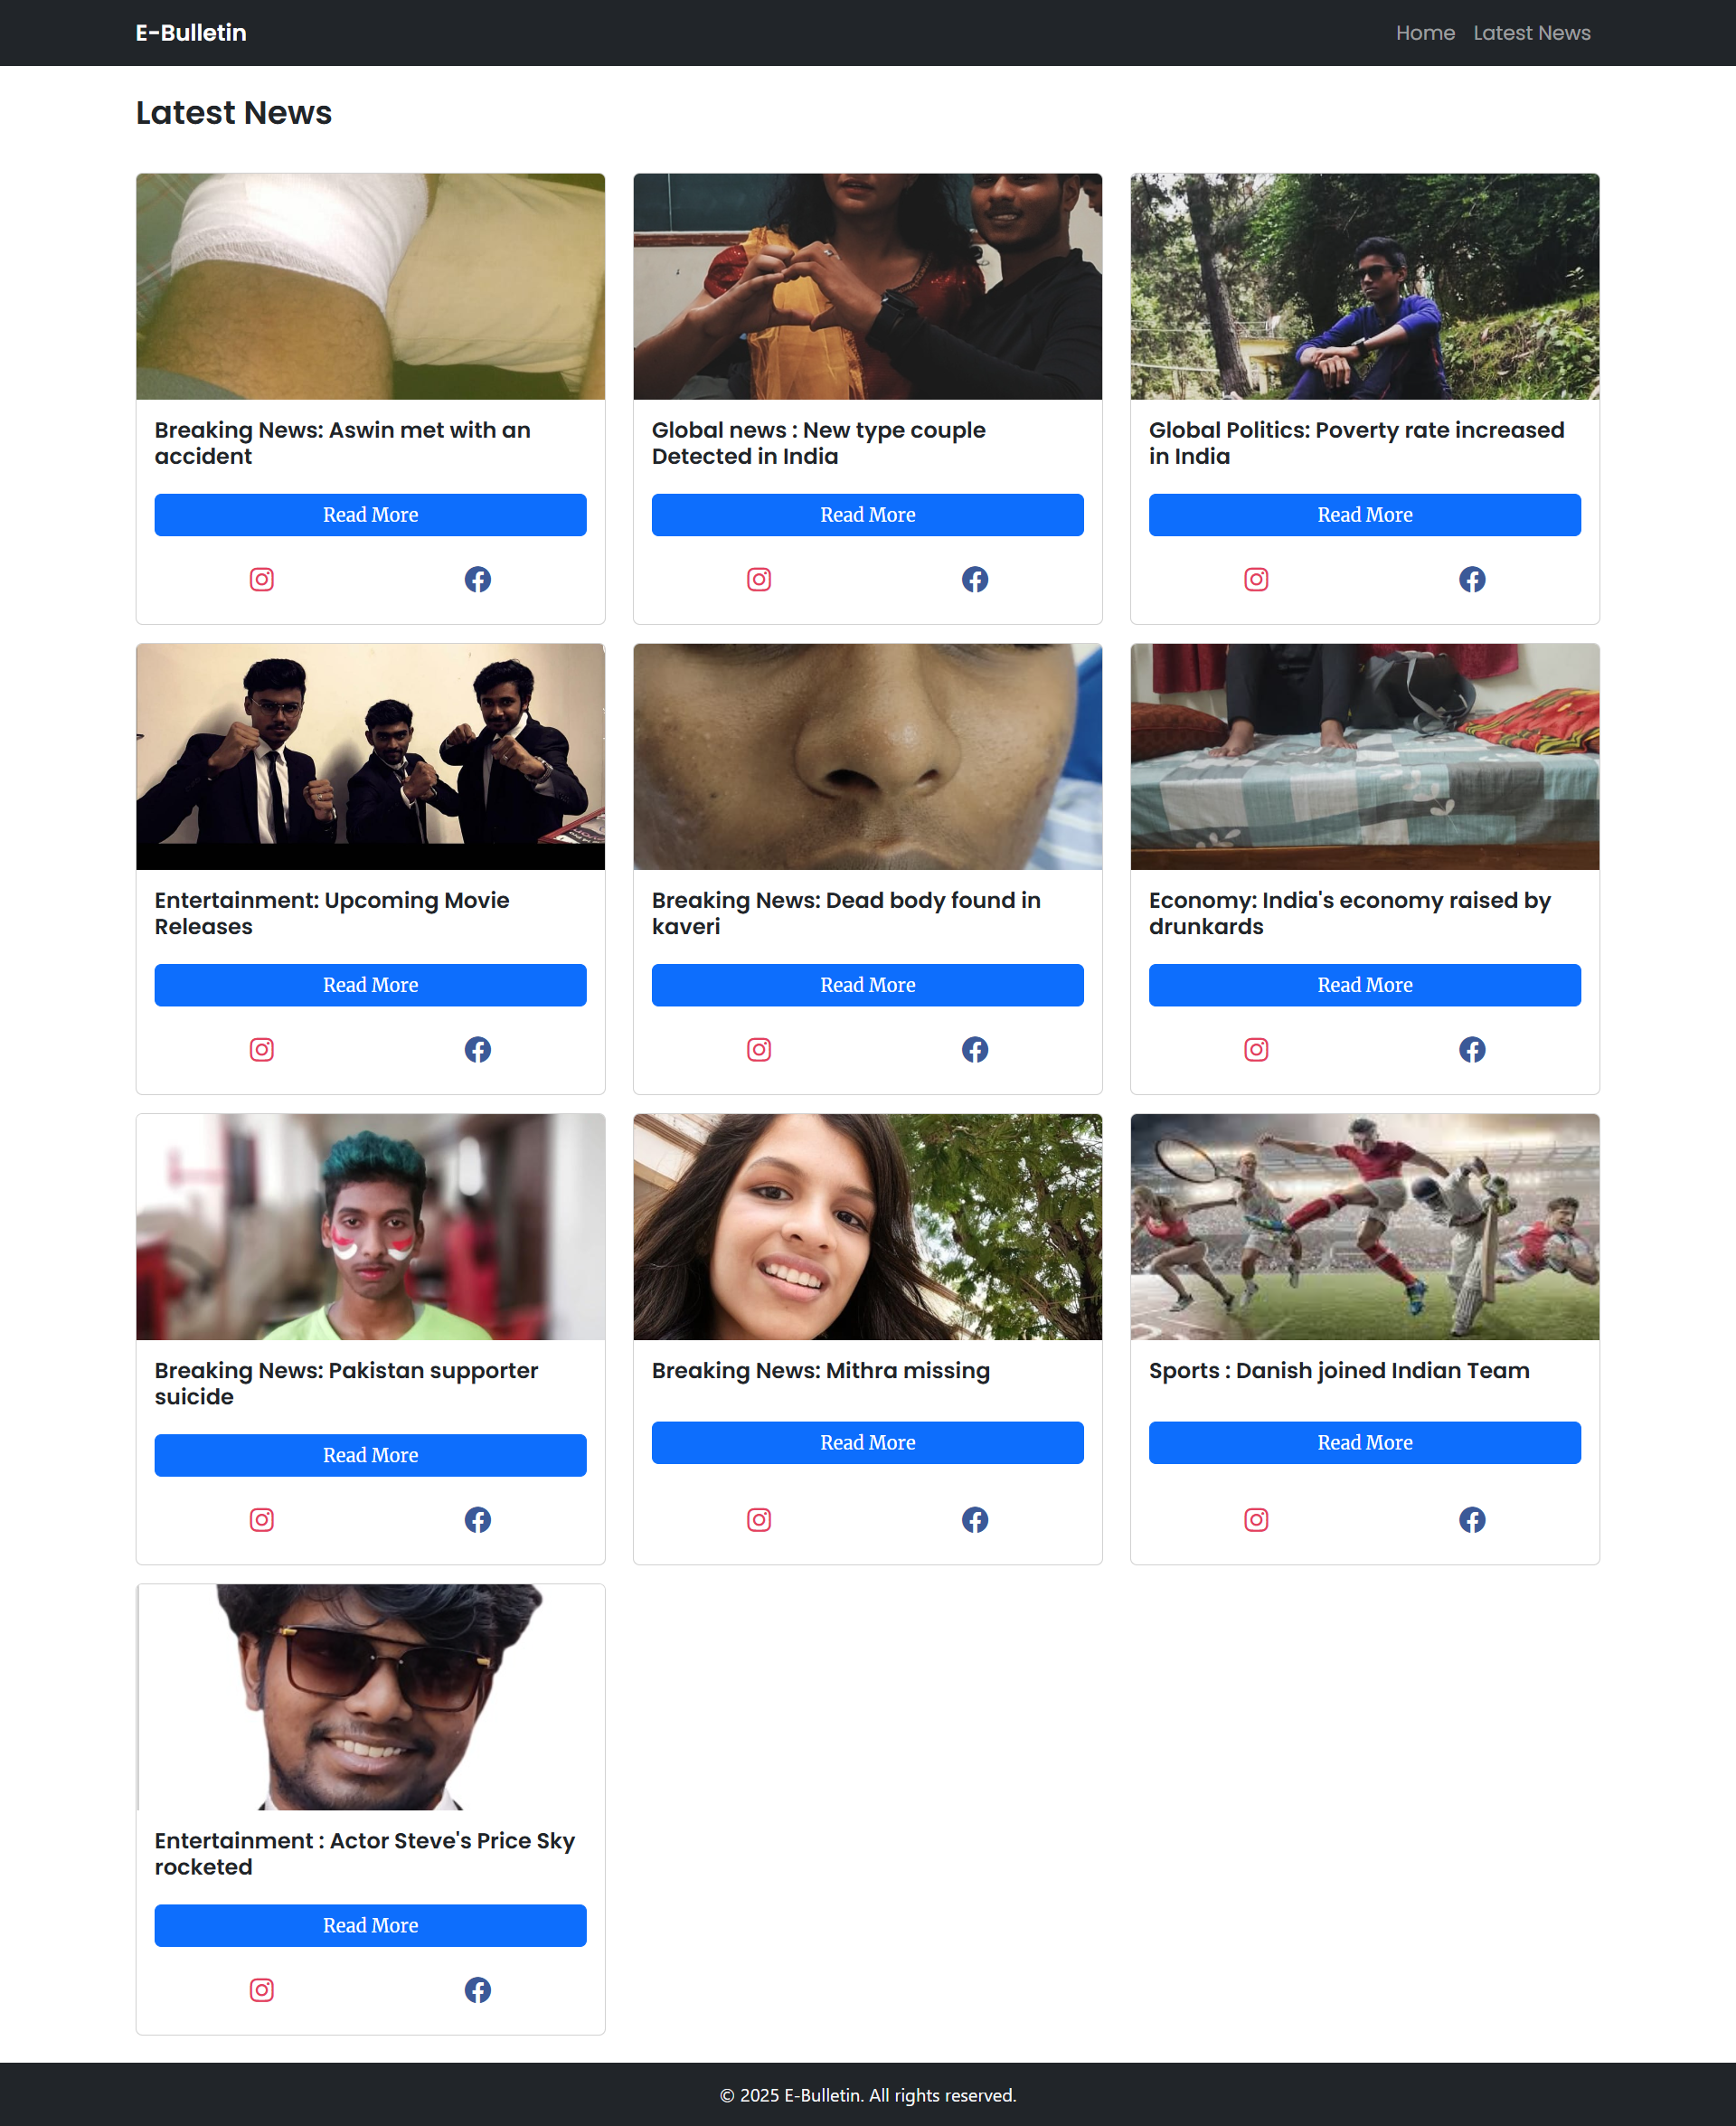

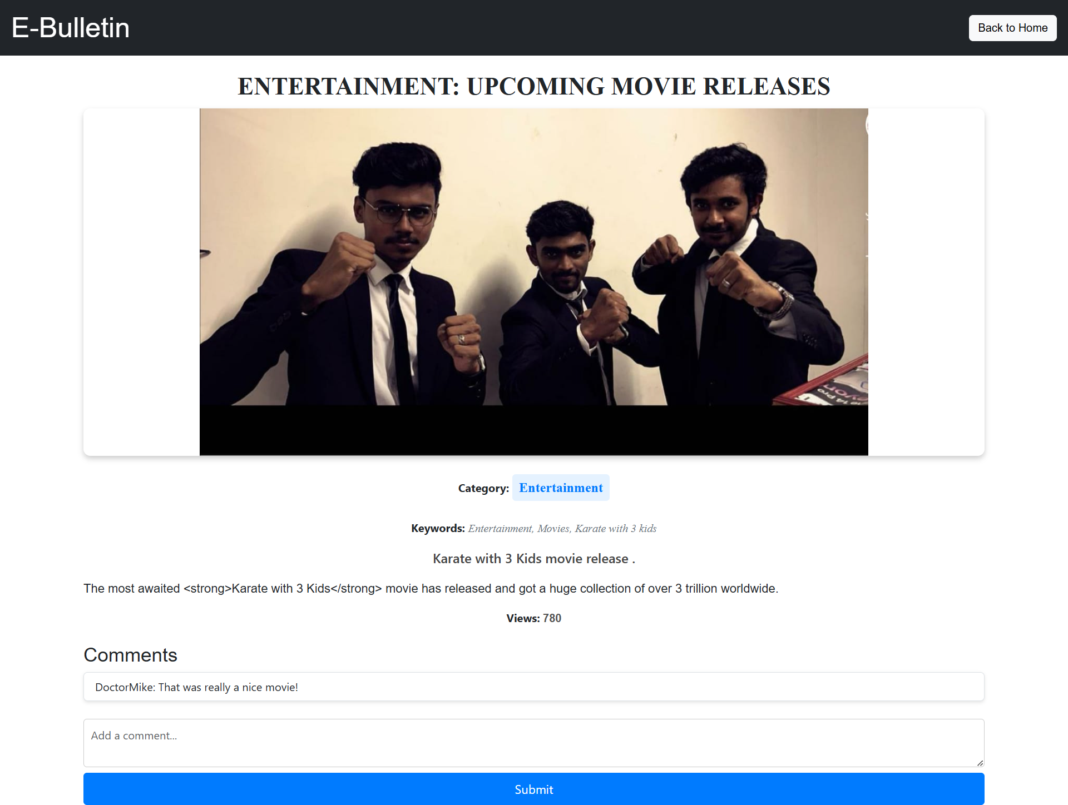

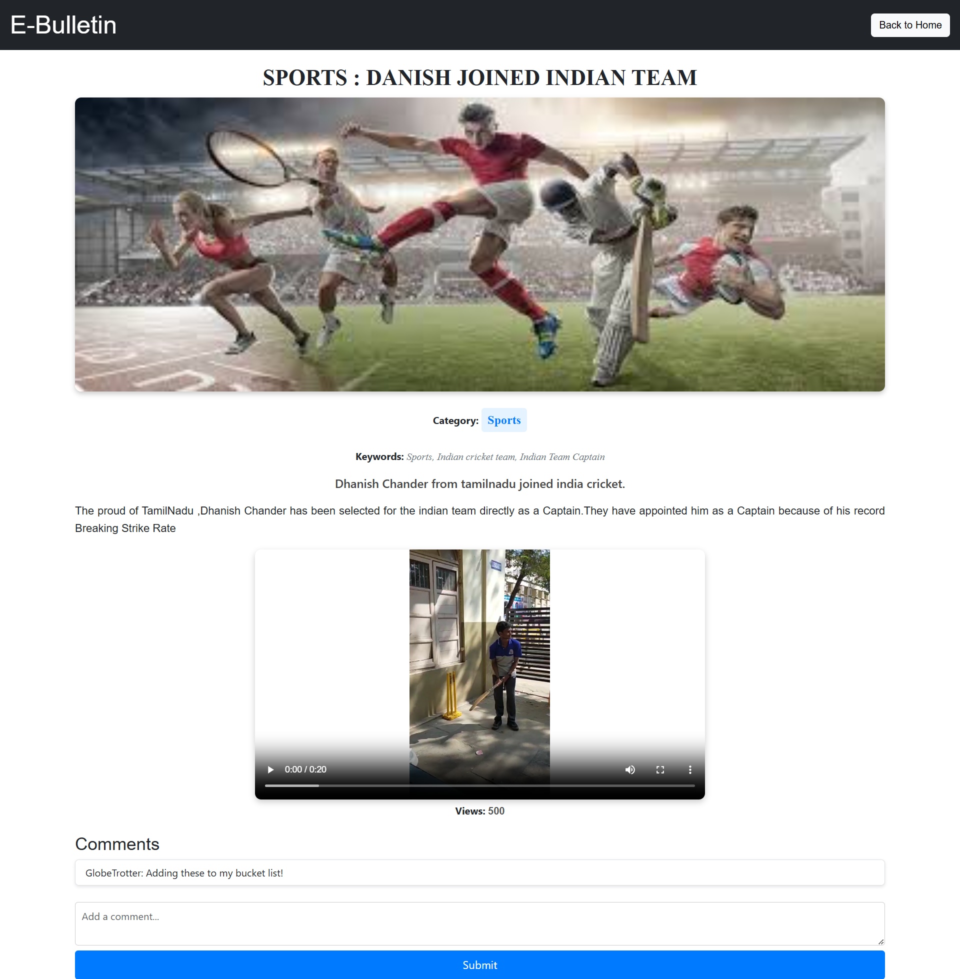

When we click read more it will redirect to article page where it has specific news about that selected  
it displays multimedia like photos and videos related to that news from the json file which acts as database

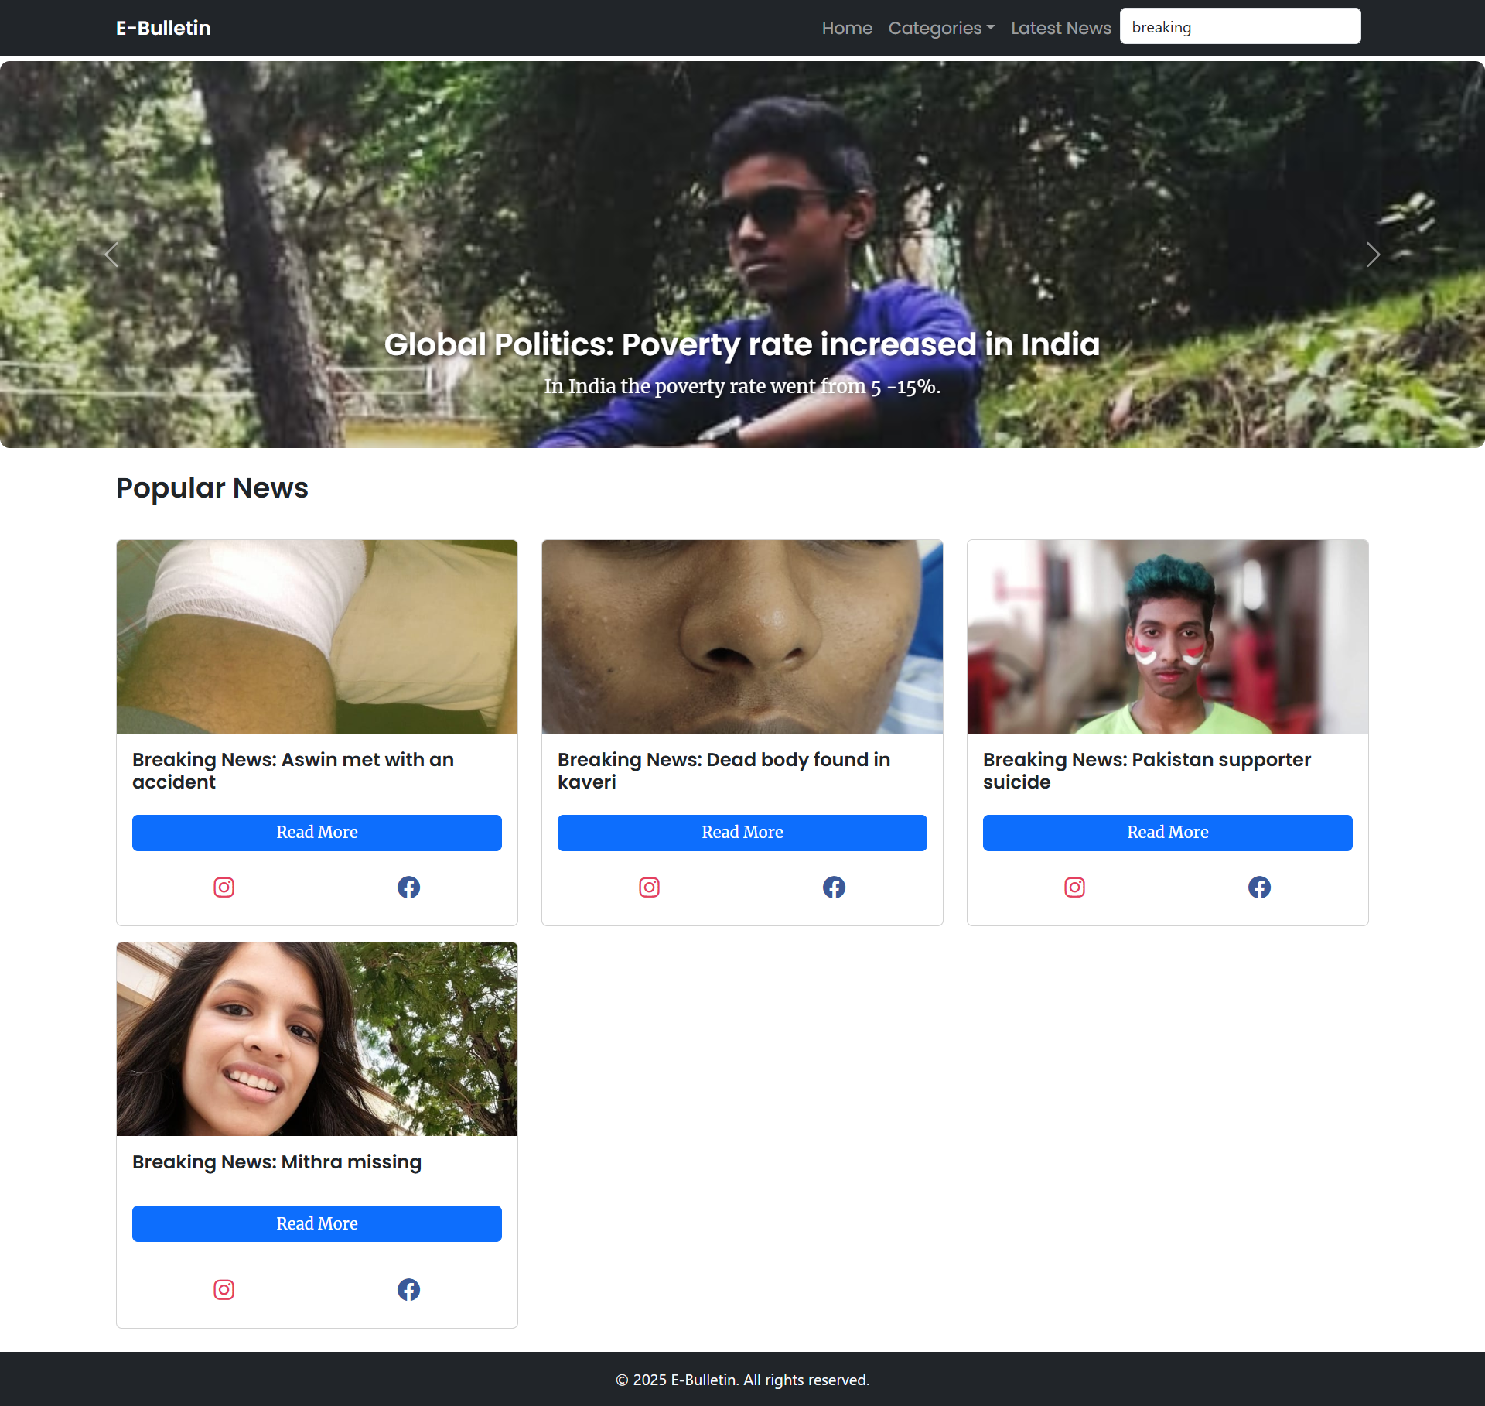

It has filter option where it will filter either by keyword and name